E-CONTENT
MJMC, SEM-IV, PAPER-XIV (CC-402)
Topic : Press Council of India
Date : 19-01-2020, TIME : 2.00 P.M.-3.00 P.M.

PREPARED BY : AMIT KUMAR

Press Council of India

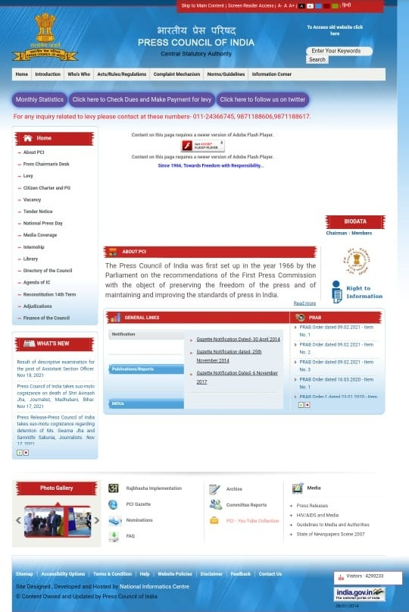

The website of press council .

The press has to be free and responsible in a democracy. The process of ensuring these by government intervention would be disastrous. Therefore an alternate system was needed. The best way is to let the peers of the profession, assisted by a few discerning laymen to regulate it through a properly structured representative impartial machinery. Thus, the Press Council was set up.
The first of its kind was established in Sweden in 1916. Soon it spread to other countries. The First Press Commission (1954) suggested setting up of a Press Council to “safeguard the freedom of the press”, “ to ensure on the part of the Press the maintenance of High standards of public taste and to foster due sense of both the rights and responsibilities of citizenship” and “ to encourage the growth of sense of responsibility and public service among all those engaged in the profession of journalism.” The Commission had concluded that the best way of maintaining professional ethics in journalism would be to bring into existence a body with statutory authority, of people principally connected with industry. As a result of the Press Council Act, 1965, Press Council of India was constituted on 4th July, 1966 as an autonomous, statutory, quasi-judicial body, with Shri Justice J R Mudholkar, then a Judge of the Supreme Court, as Chairman. The Press Council of India is a statutory quasijudicial body.

Chairmen of the Press Council
Justice J R Mudholkar, (November 16, 1966 to March 1, 1968.
Justice N Rajagopala Ayyangar (May 4, 1968 to January 1,1976), Justice A N Grover (April 3, 1979 to October 9, 1985),
Justice A N Sen (October 10, 1985 to January 18,1989)
Justice R S Sarkaria (January 19, 1989 to July 24, 1995)
Justice P B Sawant( July 24, 1995).
Justice Markandey Katju (2011-2014).
Justice Chandramauli Kumar Prasad, 2014

